River Levels – is it safe to go out?

Check on the SEPA website; http://apps.sepa.org.uk/waterlevels - The river is Nith - The station name is Greensands. There is also a link to this on our website.

It looks like this when you get the right page.
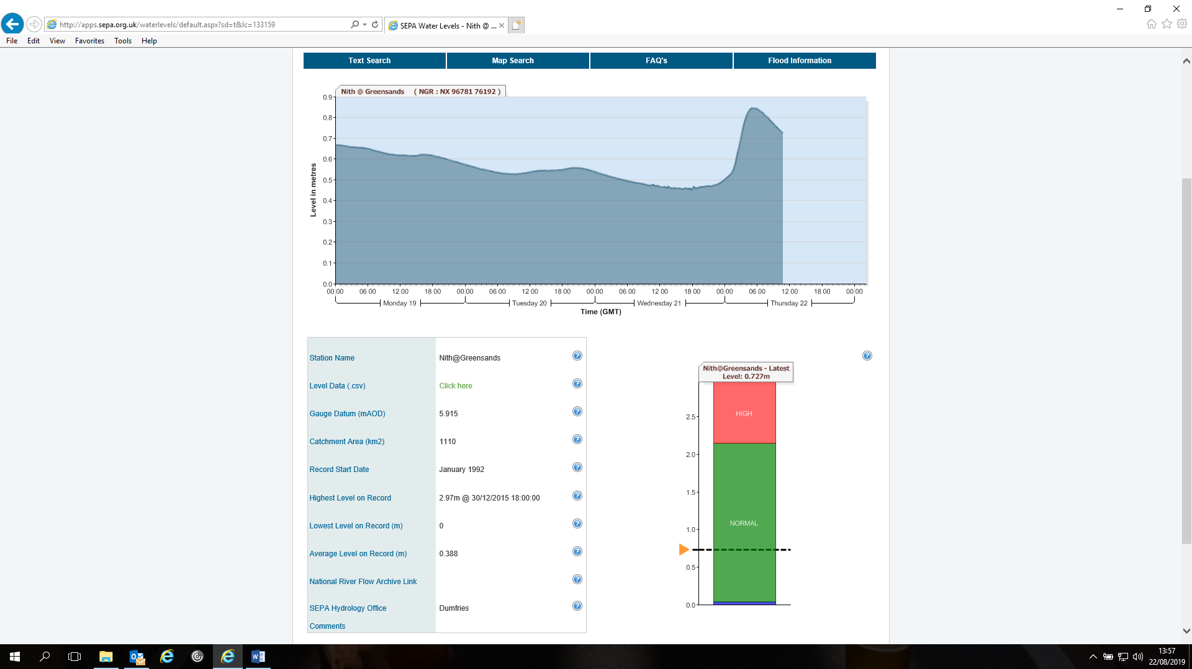

The table below shows what WE SHOULD DO as a rowing club. We just use SEPA as a guide. This table is only intended as a guide to help you understand the river levels and you should speak to someone who is knowledgeable about the river before you head out rowing. Do not go out if you are unsure.

Level | Where is the water? (roughly) | What do I do? | What boats to take out?
0.25 | Below Bottom Step | Ideal to row | Any
0.30 | Bottom Step | Rowable | Any
0.40 | Second Step ish | Rowable | 1x & 2x questionable  Bigger boats could be better
0.50 | Second Step | Check speed of the river and is there any debris? | Big boats only  No singles
0.60 | Top of Second Step | Don’t go out | None
1.00 | Top of the steps | Watch levels and check for rising tides | None
2.00 | Over the top of the steps | Tie down the equipment in the boat bay | None
2.10 | In the boat bay | Wait for the clean up! | None

