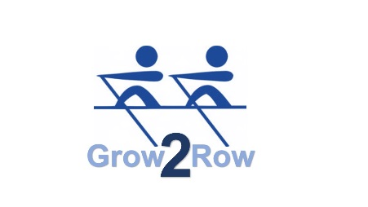



**Club Anti Bullying Statement**

Nithsdale Amateur Rowing Club acknowledges its responsibility to challenge bullying.

* This club is committed to providing a caring, friendly and safe environment for all of our members so they can participate in Rowing in a relaxed and secure atmosphere.
* Bullying of any kind is unacceptable at our club.
* If bullying does occur, all club members, parents, volunteers and coaches should be able to inform a coach or member of the committee and know that incidents will be dealt with promptly and effectively.
* This means that anyone who knows that bullying is happening is expected to tell a coach or any committee member.

**Signed on behalf of the Club by Chairperson**

**Name Emma Staniforth**

**Date 8th January 2019**