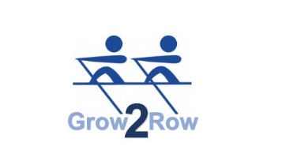



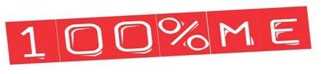

**Rowing Club 100% ME Anti-Doping Statement**

Nithsdale Amateur Rowing Club acknowledges its responsibility to promote drug free sport.

1. The key principles of the Scottish Rowing 100% ME Anti-Doping statement are to:

* Uphold and preserve the ethics of Rowing
* Safeguard the mental and physical health of players.
* Ensure that all players have the opportunity to compete equally.

1. We acknowledge that so called performance enhancing substances and social substances carry health risks, and we will endeavour to inform our players of the associated risks.
2. We acknowledge that all Rowing athletes have to abide by the Operational Rules, and as such may be tested by UK Sport. We also acknowledge that doping is an offence and may be punishable by a suspension of up to 2 years for a first offence.
3. The Rowing Club will ensure all of our players are aware of this policy and the endorsement that the club has given.

5 Further advice on Anti-Doping matters can be obtained from:

UK Anti-doping: <http://www.ukad.org.uk/>

British Rowing: <https://www.britishrowing.org/competing/anti-doping>

UK Sport – [www.uksport.gov.uk](http://www.uksport.gov.uk)

100% ME – [www.100percentme.co.uk](http://www.100percentme.co.uk)

Talk to Frank – 0800 77 66 00 – [www.talktofrank.com](http://www.talktofrank.com)

For more information of if you have any concerns about doping contact Scottish Rowing:

**Email:** amanda.cobb@scottish-rowing.org.uk

or writing to Anti Doping, Scottish Rowing, The Scottish Rowing Centre, 366 Hamilton Road, Motherwell, ML1 3ED

**Signed on behalf of the Club by Chairperson**

**Name Emma Staniforth**

**Date 8th  January 2019**